# 

# 

# Introduction

The use of remotely sensed data, such as imagery from satellites (e.g. Sentinel-2 and PlanetScope), has revolutionized the field of crop type classification. By leveraging the power of advanced imaging technologies combined with machine learning algorithms, researchers and practitioners can now identify and map different crop types over large geographic areas. This introduction provides an overview of the current approaches to crop type classification using remotely sensed data, focusing on the utilization of Sentinel-2 imagery and the integration of PlanetScope data.

Remotely sensed data, particularly satellite imagery, offers a comprehensive and synoptic view of agricultural landscapes at various spatial and temporal scales. Sentinel-2 sensors, operated by the European Space Agency (ESA), provide relatively high-resolution imagery (10m) with frequent revisits (every 5 days), allowing for the monitoring of crop growth dynamics and changes over time. The spectral information captured by Sentinel sensors, such as red, green, blue, near-infrared bands, and red-edge are essential for discriminating between different crop types based on their unique spectral signatures. Additionally, Sentinel data can be used to derive ancillary products, such as normalized difference vegetation index (NDVI) and enhanced vegetation index (EVI), which provide measures of vegetation health and vigor. These spectral and vegetation indices play a vital role in crop classification algorithms.

In recent years, machine learning approaches have emerged as powerful tools for crop type classification using remotely sensed data. Specifically, methods based on machine learning algorithms have gained recognition for their effectiveness in matching valuable spectral information from satellite imagery to observations of crop type for particular locations. Machine learning algorithms, including decision trees, random forests, support vector machines (SVM), and k-nearest neighbors (KNN), have been successfully used to classify imagery into unique agricultural types. These algorithms leverage the rich spectral information captured by satellite sensors, allowing them to identify distinctive patterns associated with different crop types. By training on large labeled datasets where ground-validation information on crop types is linked to corresponding image patches, these models can effectively learn the relationships between the spectral characteristics of crops and their respective classes.

The strength of traditional machine learning approaches lies in their ability to exploit both the spectral patterns within the remotely sensed data. For instance, decision tree-based algorithms partition the feature space based on the spectral bands, enabling the identification of different crop types based on their unique spectral signatures. Random forests extend this concept by combining multiple decision trees to improve classification accuracy and handle more complex scenarios.

Support vector machines (SVM) excel in separating different classes by constructing optimal hyperplanes in the feature space. By defining decision boundaries that maximize the margin between different crop types, SVMs can effectively discriminate between classes even in cases of overlapping spectral responses. Similarly, k-nearest neighbors (KNN) algorithms classify unknown pixels by comparing their spectral characteristics with those of neighboring training samples. This proximity-based approach allows KNN to capture spatial relationships and classify pixels based on the most prevalent crop type in their vicinity.

These traditional machine learning approaches offer advantages in terms of interpretability and computational efficiency compared to deep learning architectures. They provide insight into the decision-making process and can be more readily understood and explained by domain experts. Additionally, these methods are generally less computationally demanding and require less training data, making them suitable for applications with limited computational resources.

Field-collected data provides the necessary validation and calibration for remote sensing-based models. It serves as the benchmark against which the model's predictions are evaluated and refined. Ground truth data collected through field visits, observation, and interactions with local farmers offer essential insights into the specific crop types present in the study area. Validating and training models with accurate ground reference information ensures that the spectral patterns captured by remote sensing data are correctly associated with the corresponding crop classes. By combining the spectral information from satellite imagery with ground truth data, researchers can develop robust models that effectively differentiate between different crop types based on their unique spectral signatures.

An emerging trend in crop type classification is the integration of data from sensors like PlanetScope, which provide detailed information on plant phenology and physiological traits. PlanetScope sensors measure various indicators at a fine-grained scale. These data can be used in conjunction with publicly available satellite imagery to enhance the accuracy of crop type classification models. For instance, combining spectral information from Sentinel imagery with physiological traits derived from PlanetScope data can improve the discrimination between crop types that may exhibit similar spectral responses but differ in physiological characteristics - particularly in developing countries where intercropping and small plots are the norm.

The integration of remotely sensed data from Sentinel-2 and PlanetScope presents exciting opportunities for advancing crop type classification. The synergistic use of high-resolution imagery, spectral indices, and physiological traits enables researchers to capture both spectral and functional diversity among different crops. Furthermore, the availability of open data sources, such as the Copernicus Open Access Hub for Sentinel data or GoogleEarthEngine, and the increasing accessibility of PlanetScope sensors, contribute to the democratization of crop classification methodologies, empowering a broader community of researchers and practitioners to engage in this field.

# Methods

## Data and Study Area

Mwanza, located in the northern region of Tanzania, is a vibrant area known for its agricultural activities. Situated along the southern shores of Lake Victoria, Mwanza enjoys fertile soils and a favorable climate for agricultural production. The region is characterized by vast plains and rolling hills, creating a diverse landscape suitable for various types of farming. Agriculture plays a crucial role in the economy of Mwanza. The primary agricultural activities in the region include crop cultivation and livestock rearing. Maize, rice, cotton, sorghum, millet, sunflower, and groundnuts are some of the key crops grown in the area. Farmers practice both subsistence and commercial farming, with small-scale farmers being predominant.

## Field Data Collection

In order to gather comprehensive information on the agricultural landscape in Mwanza, we employed the use of KoboCollect, a mobile data collection tool, and conducted surveys over a period of four days (2 consecutive weekends), from April 25th to May 7th, 2023. Participants visited 11 wards and collected 552 points. The surveys included gathering essential information such as the primary crop type, field size, a basic indicator of growth stage, and information useful for validation purposes such as Kobo user names, team names, and links to images of the field. Field sizes were determined to be large if they were greater than 160,000m2 , medium between that and 2,500m2, and small otherwise. The most common crop types observed in the Mwanza area were rice, maize, cassava, and vegetables, as depicted in Figure 1.

We also leverage qualitative variables captured by the data collection team. For instance, to account for field size, we buffer fields classified as small by 10 meters, medium by 20m and large by 30m. Therefore the number of pixels of satellite data leveraged in our models scales with field size. We also filter out low quality observations using the image validation procedures described later in the methods section.

## Imagery

The Sentinel-2 satellite mission captures data in various spectral bands, each providing unique information about the Earth's surface. One of the derived indices from Sentinel-2 is the Enhanced Vegetation Index (EVI), which is calculated using multiple bands and designed to improve vegetation monitoring, especially in areas with dense canopies or atmospheric interference. It provides insights into vegetation density, vigor, and overall health. We also extract Hue. Hue is another derived index that characterizes the dominant color or hue of an image pixel. It is useful for analyzing color variations and can assist in land cover classification, object recognition, and mapping applications.Hue might help to differentiate crops with strong color signals like sunflowers or cotton. We also use Band 2, 5, 6, 11, and 12 as further indicators to help differentiate crop types (Table 1).

*Table 1: Sentinel 2 bands and derived products*

| **Band** | **Resolution** | **Central Wavelength** | **Description** |
| --- | --- | --- | --- |
| EVI | 10 m |  | Enhanced Vegetation Index |
| Hue | 10 m |  | Dominant hue (color) translated to degrees |
| B2 | 10 m | 490 nm | Blue |
| B5 | 20 m | 705 nm | Visible and Near Infrared (VNIR) |
| B6 | 20 m | 740 nm | Visible and Near Infrared (VNIR) |
| B11 | 20 m | 1610 nm | Short Wave Infrared (SWIR) |
| B12 | 20 m | 2190 nm | Short Wave Infrared (SWIR) |

## Summary Statistics

In this study, we are conducting crop type classification using machine learning techniques. To improve the accuracy of the classification model, we extract a set of statistical features on a *pixel-by-pixel* basis from Sentinel-2 satellite imagery data. Summary statistics were extracted from Sentinel-2 bands plus vegetation indices (EVI) and hue (a measure of color in degrees) for two specific periods: September 2022 to March 2023 (Vuli growing season) and March 2023 to August 2023 (Masika growing season). The data were interpolated to fill missing values, and the features were extracted using a dictionary of time-series features.

These time series features capture important characteristics of the time series data associated with different crops. The extracted features include measures such as minimum and maximum values, mean and median values, standard deviation and variance, skewness and kurtosis, day of the year of maximum values, and various other statistical properties. These features provide insights into the distribution, variability, and overall shape of the time series data. We also consider temporal properties by examining the autocorrelation at different lags, quantiles representing specific percentiles of the data, and the presence of trends over time. These temporal features help capture patterns and dependencies in the time series, which can be indicative of specific crop types. Moreover, we explore features related to the occurrence of certain values, such as the day of the year when the maximum or minimum value occurs. This information can be valuable for distinguishing between different crops that exhibit distinct growth patterns during specific periods.

By incorporating these extracted time-series features into our machine learning model, we aim to enhance its ability to differentiate between different crop types based on the patterns and characteristics observed in the imagery. The summary statics used include:

*Table 2: Time series summary statistics*

| **Statistic** | **Description** |
| --- | --- |
| Absolute Energy | Sum of squared values of the time series |
| Absolute Sum of Changes | Sum of absolute differences between consecutive values |
| Autocorrelation (1 & 2 month lag) | Correlation between the time series and its lagged values |
| Count Above Mean | Number of values above the mean |
| Day of Year of Maximum Value | Day of the year when the maximum value occurs |
| Day of Year of Minimum Value | Day of the year when the minimum value occurs |
| Kurtosis | Measure of the tailedness of the time series distribution |
| Linear Time Trend | Linear trend coefficient estimated over the entire time series |
| Longest Strike Above Mean | Longest consecutive sequence of values above the mean |
| Longest Strike Below Mean | Longest consecutive sequence of values below the mean |
| Maximum | Maximum value of the time series |
| Mean | Mean value of the time series |
| Mean Absolute Change | Mean of absolute differences between consecutive values |
| Mean Change | Mean of the differences between consecutive values |
| Mean Second Derivative (Central) | Mean of the second derivative of the time series |
| Median | Median value of the time series |
| Minimum | Minimum value of the time series |
| Quantile (q = 0.05, 0.95) | Values representing the specified quantiles (5th and 95th percentiles) |
| Ratio Beyond r Sigma (r=1,2,3) | Proportion of values beyond r standard deviations from the mean |
| Ratio of Value Number to Time Series Length | Ratio of the number of values to the length of the time series |
| Skewness | Measure of the asymmetry of the time series distribution |
| Standard Deviation | Standard deviation of the time series |
| Sum Values | Sum of all values in the time series |
| Symmetry Looking | Measures the similarity of the time series when flipped horizontally |
| Time Series Complexity (CID CE) | Complexity of the time series using the Complexity-Invariant Distance |
| Variance | Variance of the time series |
| Variance Larger than Standard Deviation | Proportion of values with variance larger than the standard deviation |

For details on any particular summary statistic please download and open the following [html file](https://drive.google.com/file/d/1BET1Hm0OqnZlFZz4AtJcKNpx-wFDPti1/view?usp=sharing).

## Classification

In our study, we aim to classify pixels based on their crop type using time-series properties described above. This involves analyzing data collected over time to understand how different crops change and behave throughout the growing season. We explore two main approaches: supervised and unsupervised.

In the supervised approach, we train our model using labeled data collected by YouthMappers, where each pixel is associated with a known crop type. By analyzing the time-series properties of these labeled pixels, the model learns to recognize patterns and make predictions for unseen pixels. This approach requires a significant amount of labeled data and relies on human experts to manually assign crop types for training.

On the other hand, the unsupervised approach does not rely on labeled data. Instead, it identifies patterns and structures within the time-series data itself. The model groups similar pixels together based on their temporal behavior, forming clusters or classes. These classes may not directly correspond to specific crop types, but they provide insights into the temporal variations and similarities within the dataset. Unsupervised methods can be useful for discovering hidden patterns or identifying distinct temporal profiles that may represent different crop types

## Model Selection

In our study, we employ a technique called hyperparameter optimization to choose and fine-tune the classifiers used for crop type classification. This process aims to identify the best configuration of a classifier that maximizes its performance in accurately predicting the crop types. To achieve this, we leverage a powerful optimization framework called Optuna. The objective is to find the optimal set of hyperparameters for each classifier that maximizes a performance metric known as balanced accuracy. Balanced accuracy measures the ability of a classifier to make accurate predictions across all crop types, taking into account imbalances in the dataset.

The optimization algorithm explores different combinations of classifier types and their corresponding hyperparameters. For each trial, the algorithm suggests values for hyperparameters such as regularization strength, kernel type, and maximum depth of decision trees. It then trains and evaluates the classifier using cross-validation, which assesses its performance on multiple subsets of the data. The algorithm iteratively searches for the best combination of classifier and hyperparameters by evaluating their performance based on the balanced accuracy metric. By considering a range of classifier types (e.g., Support Vector Machines, Random Forest, LightGBM) and exploring various hyperparameter settings, we aim to find the configuration that achieves the highest balanced accuracy and thus the best predictive performance for crop type classification.

The outcome of this step is to find the ideal classifier and its parameters to achieve the most accurate classification possible.

## Feature Selection

In our crop type classification study, we employ a technique called SHAP (SHapley Additive exPlanations) to gain insights into the important factors that influence our classification model's predictions (Lundberg, 2017). SHAP helps us understand the relationships between different features and the crop types we aim to classify.

To do this we then divide the dataset into a training set and a testing set. The training set is used to train the LightGBM model, enabling it to learn patterns and make predictions about crop types. The testing set is reserved for evaluating the model's performance and its ability to generalize to new, unseen data. Using SHAP, we gain insights into the importance of different features in our classification model. SHAP calculates the contribution of each feature to the predictions made by the model. By visualizing the feature importance through bar plots, we can identify the features that have the most significant impact on crop type classification. Higher values in the plots indicate features that strongly influence the predictions. We utilize both the abs mean shaps values in order to capture those variables that are most important on average, and the abs max shaps values to capture variables that are important in edge cases.

Understanding feature importance provides valuable knowledge about the underlying factors driving accurate predictions. It helps us uncover the relationships between different crop characteristics and their corresponding types. By incorporating SHAP, we enhance the interpretability and transparency of our crop type classification model, making it more reliable and understandable for both experts and general audiences.

In the next step, we limit the input data to those features selected by SHAP as the most relevant to our classification task.

## Effectiveness of YM land use data

One of the primary objectives of our project is to assess the effectiveness of the land use data collected by YouthMappers in the spring of 2023. This data serves as a crucial reference for validating and training our classification models. To evaluate the quality and reliability of this data, we propose three approaches.

To visually evaluate the quality of the collected data, we present a 3x4 matrix showcasing randomly selected ground truth images along with the corresponding identified crop types provided by the YouthMappers team members. Each image is accompanied by the labeled crop type displayed below it. This visual assessment allows us to gain a broad understanding of the data collection capabilities of the YouthMappers teams and enables post hoc validation. For the remaining images, we have conducted an evaluation and assigned quality scores to determine whether a specific training point should be deleted or categorized as low, medium, or high quality. These scores can be further analyzed by user, team, or crop type, providing valuable insights into the factors influencing the occurrence of errors. By delving into the breakdown of these scores, we can identify the drivers of data quality issues and gain a more comprehensive understanding of the challenges associated with the dataset.

Second, we will compare the accuracy of a supervised model trained on the YouthMappers data to that of a "naive" or unsupervised model. The supervised model leverages the labeled ground truth data to learn and predict crop types based on the time-series properties of pixels. By evaluating its performance, we can assess the extent to which the YouthMappers data effectively captures and represents the true crop types. In contrast, the unsupervised model does not rely on labeled data but rather explores patterns and structures within the data itself. By comparing the accuracy of the supervised model to that of the unsupervised model, we can gain insights into the added value of the YouthMappers data in improving classification accuracy.

Third, we will compare the accuracy of our models to those of similar studies conducted with data collected by professionals (e.g. Kpienbaareh et al 2021) . This comparative analysis allows us to understand how the YouthMappers data measures up against data collected using traditional and often more expensive methods. By examining the performance metrics of our models in relation to the results reported in other studies, we can evaluate the reliability and credibility of the YouthMappers data. This comparison provides valuable insights into the potential of crowdsourced data collection efforts in achieving comparable accuracy to professional data collection.

## Results

### Field Data Collection

As part of the field data collection YouthMappers collected the primary (Figure 1) and, in the case of intercropping, secondary crop types (Figure 1) for each field site. The data collected shows that among the crops grown in Mwanza, rice is overwhelmingly the dominant crop type based on total count, followed by Maize.

*Figure 1: Land use observations by crop type for Mwanza area*

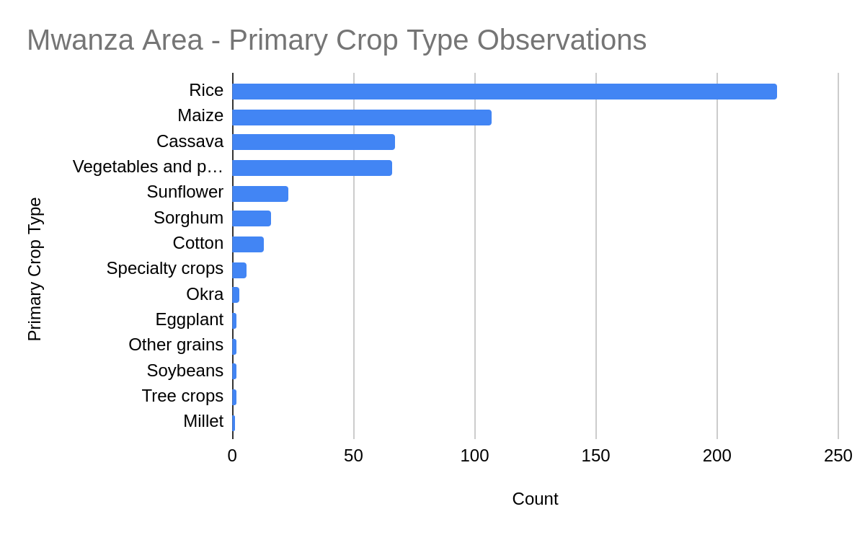

Secondary crop types were collected when a site was intercropped. While close to 70% of sites were not intercropped the other 30% were intercropped in a variety of ways, with the most common being maize, vegetables/pulses, and sunflowers.

*Figure 2: Histogram of secondary crop type reported*

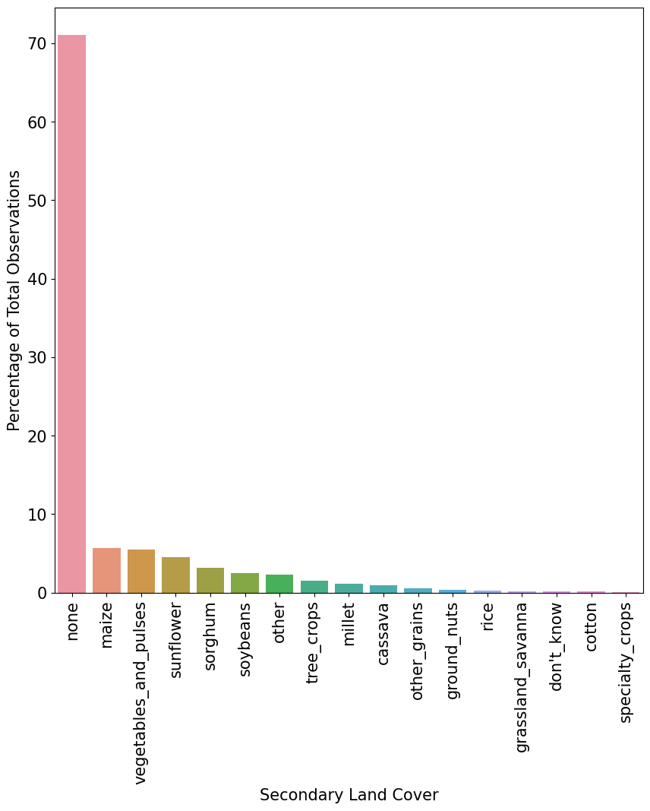

### Image Quality Assessment

The following section presents the results of the visual validation of the collected data. Each photo of the field was evaluated to see if it provided a meaningful confirmation of the labeled crop class. As described in the methods section, each observation was assigned a quality score of “Delete” for an invalid observation, and low, medium, and high values to assess the quality of data collected. Below we break down the scores by username, team, and crop:

*Table 3 - Image quality counts by Kobo user name*

|  | **Quality** | **Percent** |
| --- | --- | --- |
| Person A | Delete | 2.6% |
|  | Low | 5.1% |
|  | Medium | 2.6% |
| Person B | Delete | 2.4% |
|  | Low | 1.2% |
|  | Medium | 1.2% |
| Person C | Delete | 1.9% |
|  | Low | 1.0% |
|  | Medium | 4.9% |
| Person D | Delete | 4.1% |
|  | Low | 0.8% |
|  | Medium | 2.5% |
| Person E | Delete | 16.7% |
| shemaps2 | Delete | 2.6% |
|  | Low | 3.7% |
|  | Medium | 2.9% |
| username not found | Delete | 50.0% |

*Table 4 - Image quality counts by YouthMappers team*

| **Team** | **Quality** | **Percent** |
| --- | --- | --- |
| A | Delete | 2.5% |
|  | Low | 1.2% |
|  | Medium | 1.6% |
| B | Delete | 1.1% |
|  | Low | 5.3% |
|  | Medium | 1.1% |
| C | Delete | 2.0% |
|  | Low | 1.3% |
|  | Medium | 3.8% |
| D | Delete | 2.5% |
|  | Low | 4.6% |
|  | Medium | 3.2% |
| E | Delete | 100.0% |

Table 5 *- Image quality counts by crop type*

| **Crop** | **Quality** | **Percent** |
| --- | --- | --- |
| cassava | Delete | 1.2% |
|  | Low | 10.5% |
|  | Medium | 2.3% |
| cotton | Delete | 5.6% |
|  | Low | 1.9% |
|  | Medium | 5.6% |
| maize | Delete | 4.4% |
|  | Low | 3.3% |
|  | Medium | 2.7% |
| millet | Delete | 0.7% |
| peanuts | Delete | 6.7% |
|  | Low | 6.7% |
|  | Medium | 20.0% |
| rice | Delete | 2.1% |
|  | Low | 0.4% |
|  | Medium | 0.4% |
| sorghum | Delete | 1.3% |
|  | Low | 13.3% |
|  | Medium | 13.9% |
| soybeans | Delete | 15.4% |
| sunflower | Delete | 1.7% |
|  | Low | 1.7% |
|  | Medium | 1.7% |
| vegetables | Delete | 2.0% |
|  |  |  |

Quality assessments were carried out using a matrix of collected images with their assigned crop classification. In this section we present some examples of the images captured by the YM teams and the labels assigned to them.

*Figure 3: Examples of land use data labeled maize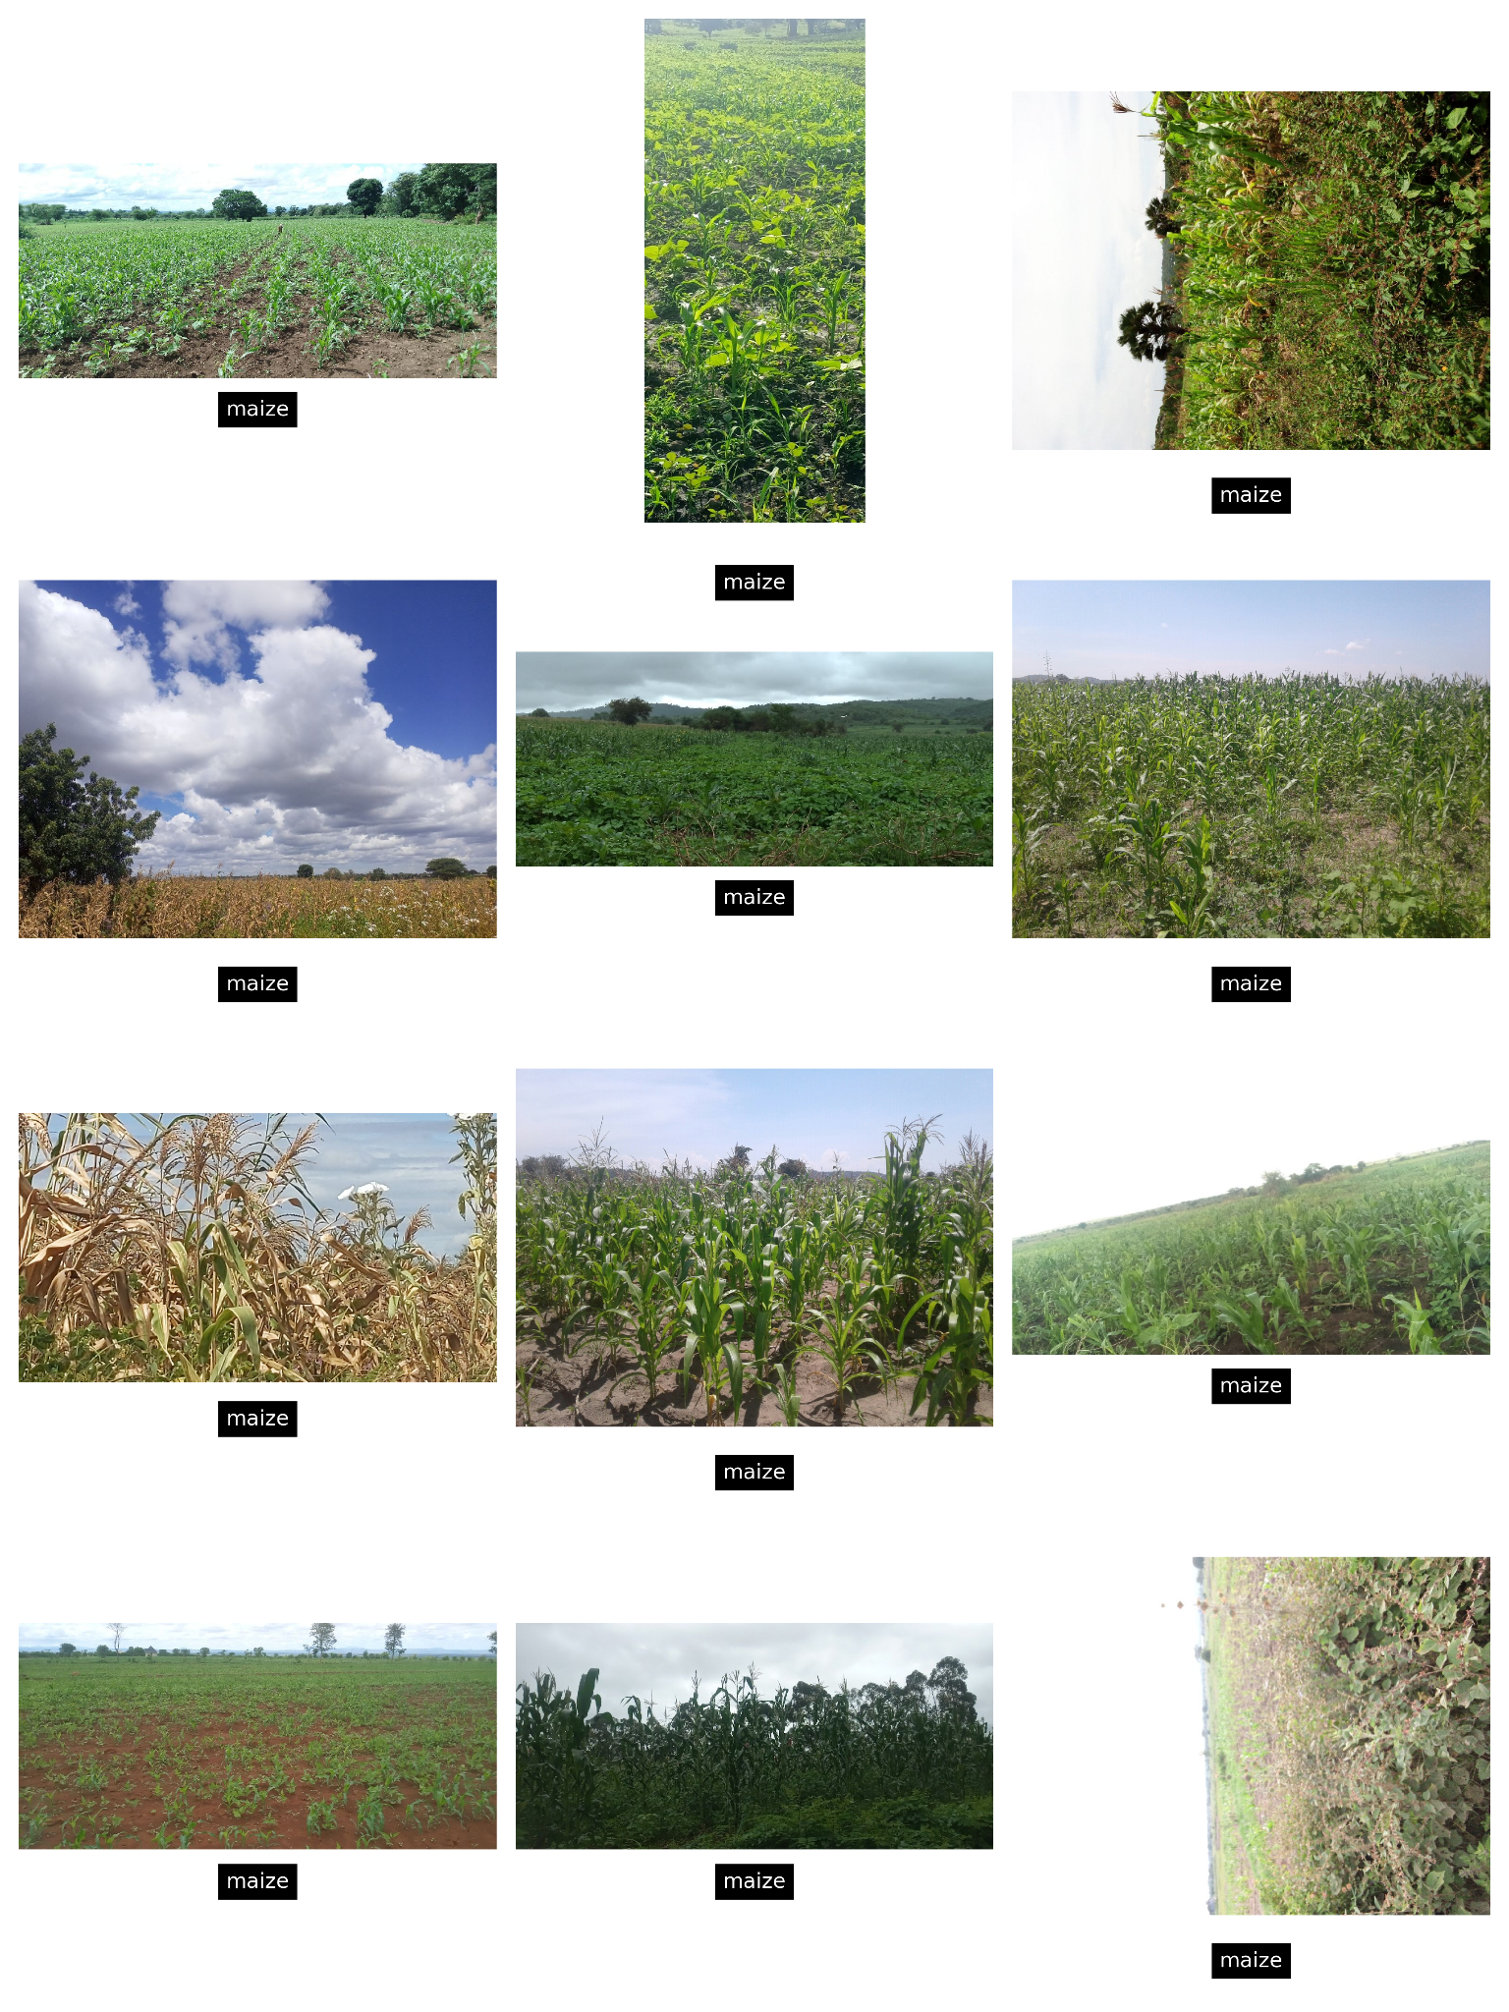*

*Figure 4: Examples of land use data labeled Rice*

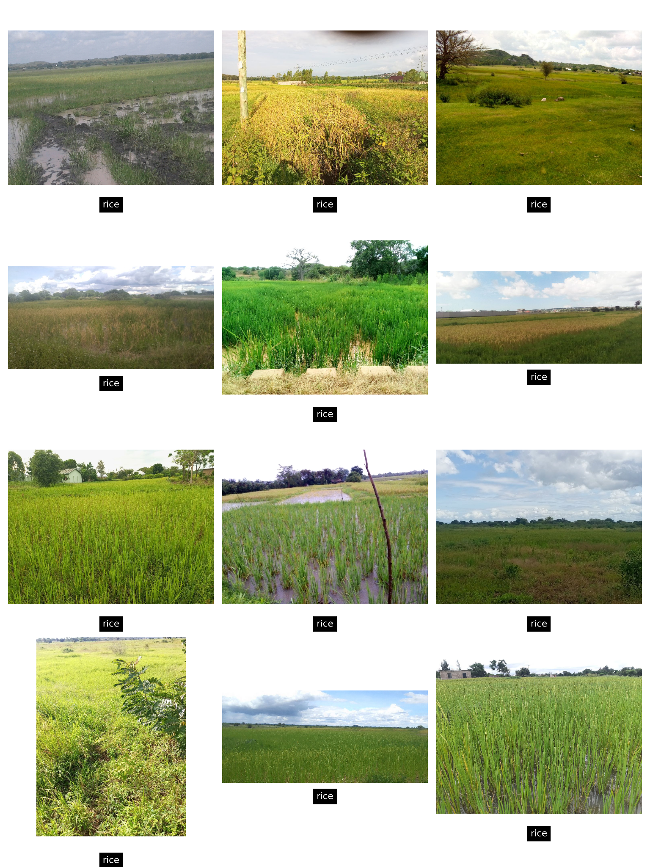

*Figure 5: Examples of land use data labeled Cassava*

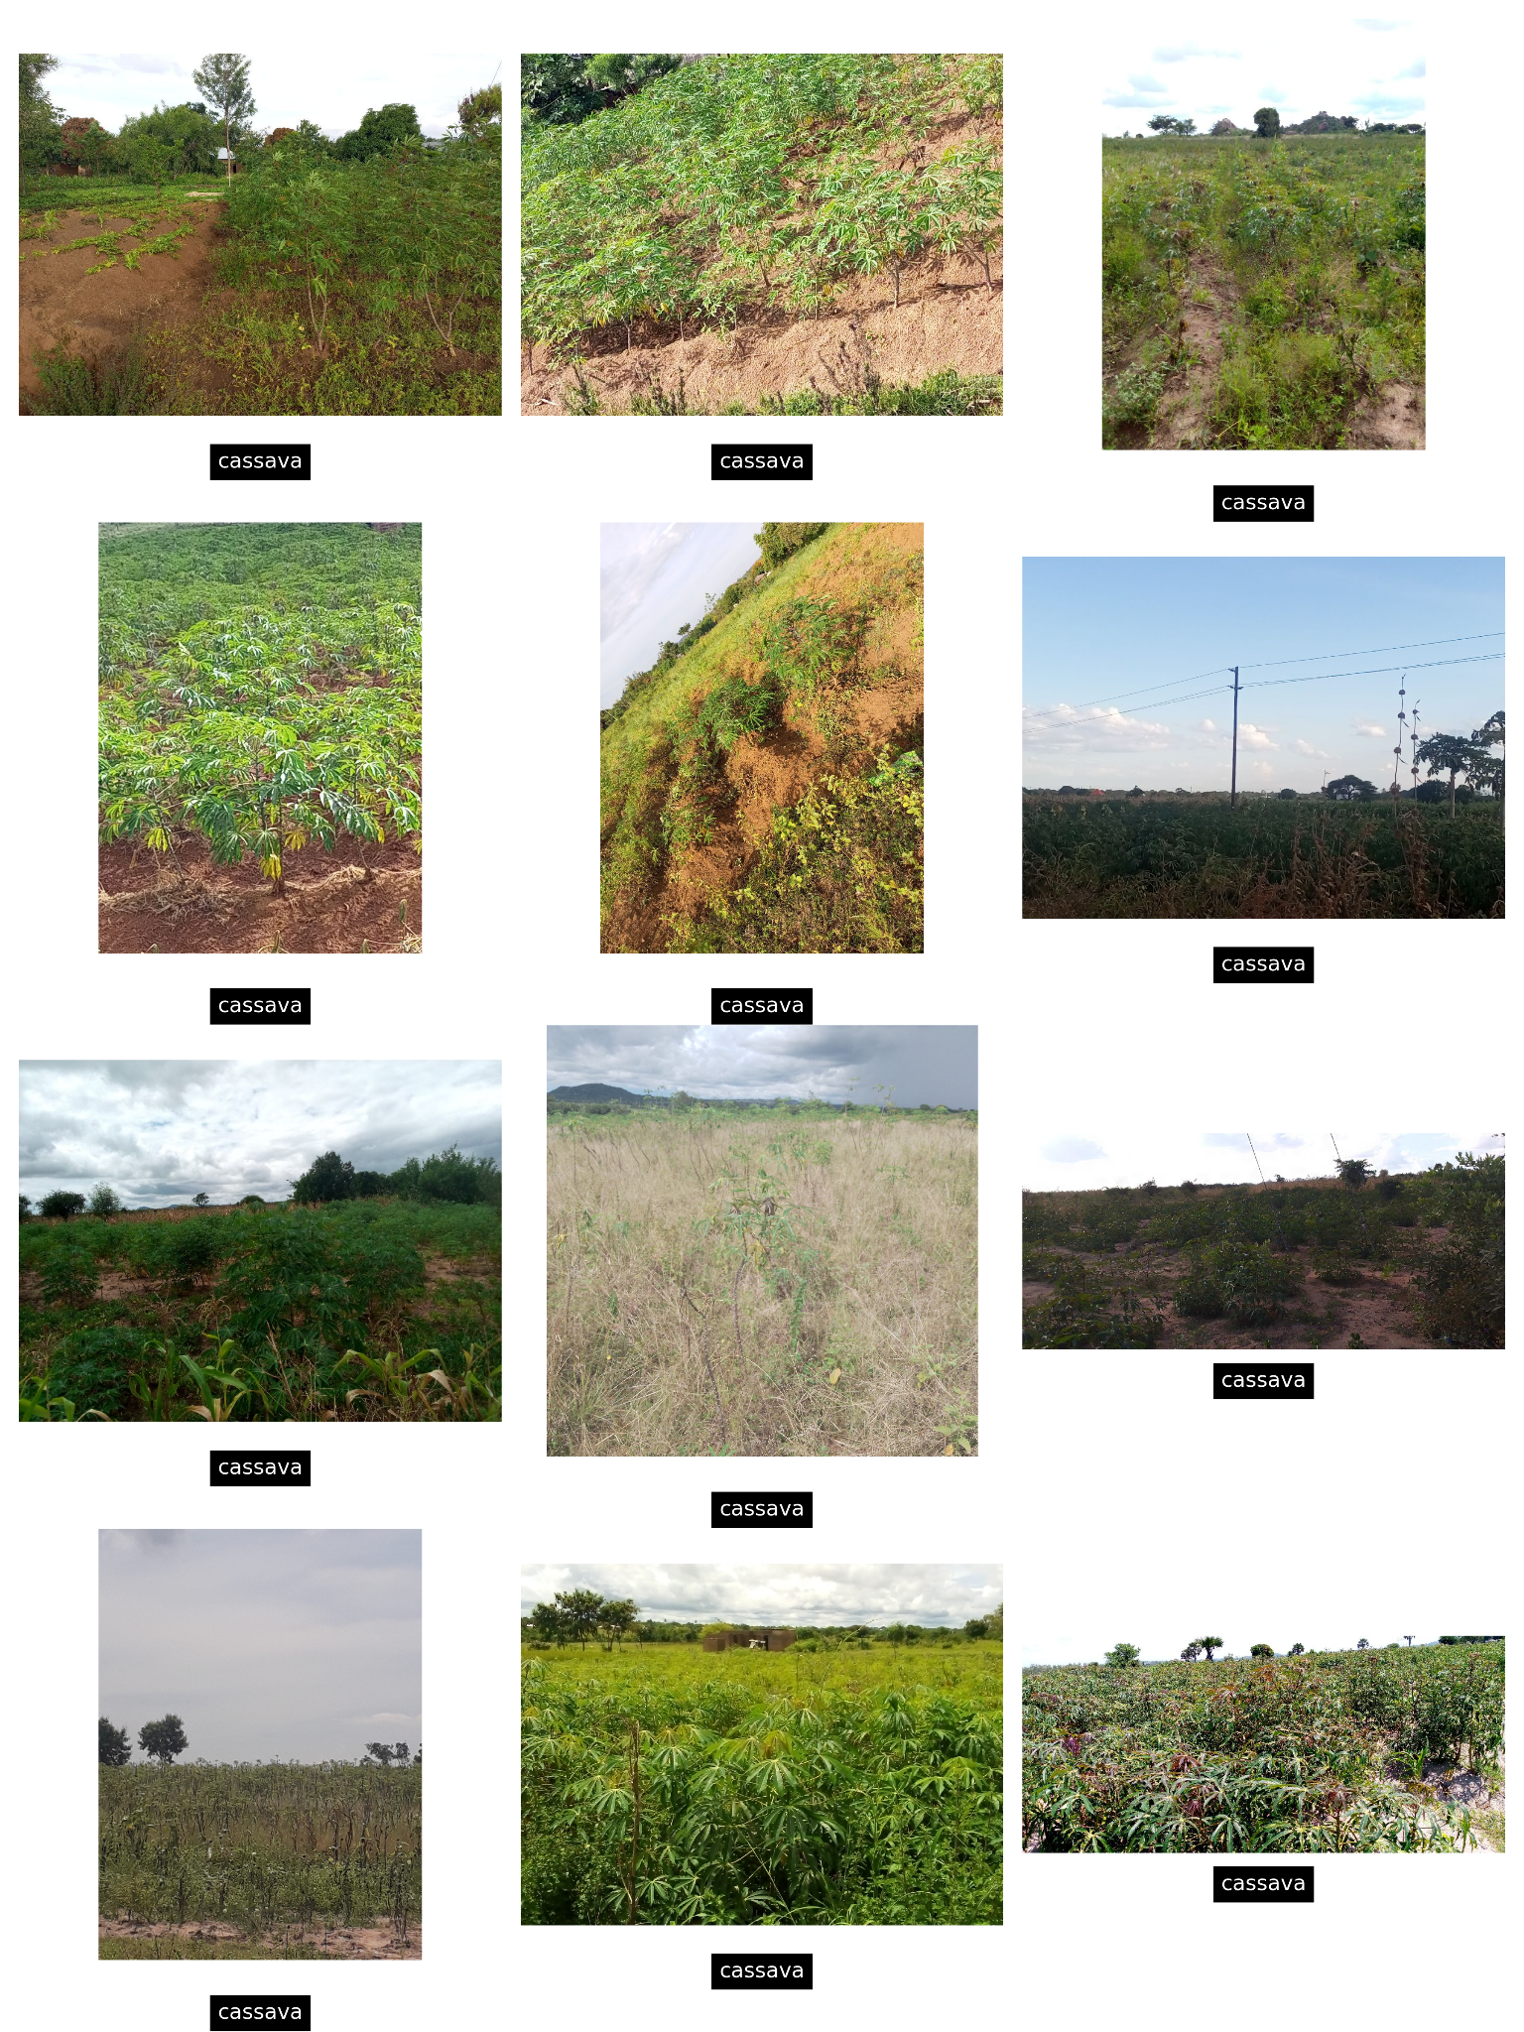

*Figure 6: Examples of land use data labeled Sunflower*

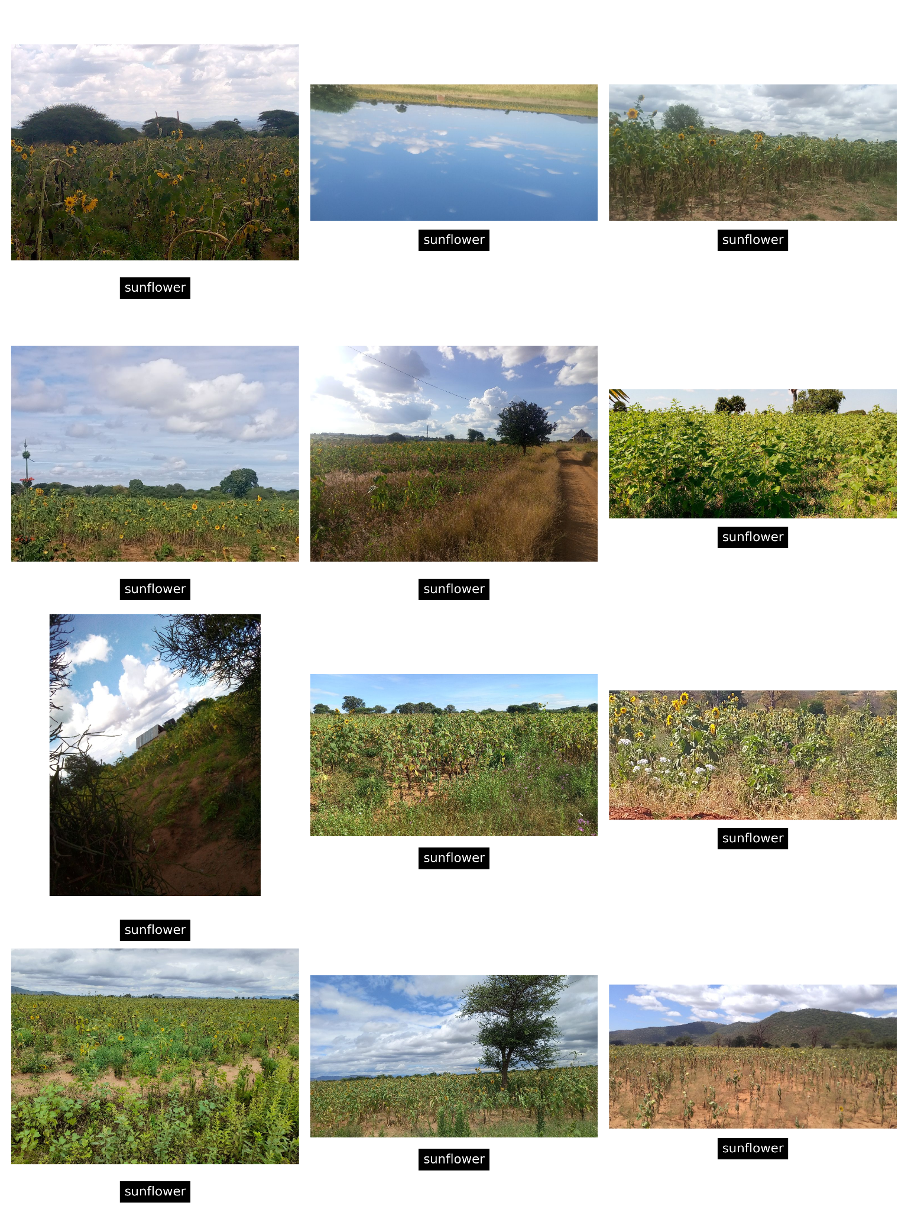

*Figure 7: Examples of land use data labeled Sorghum*

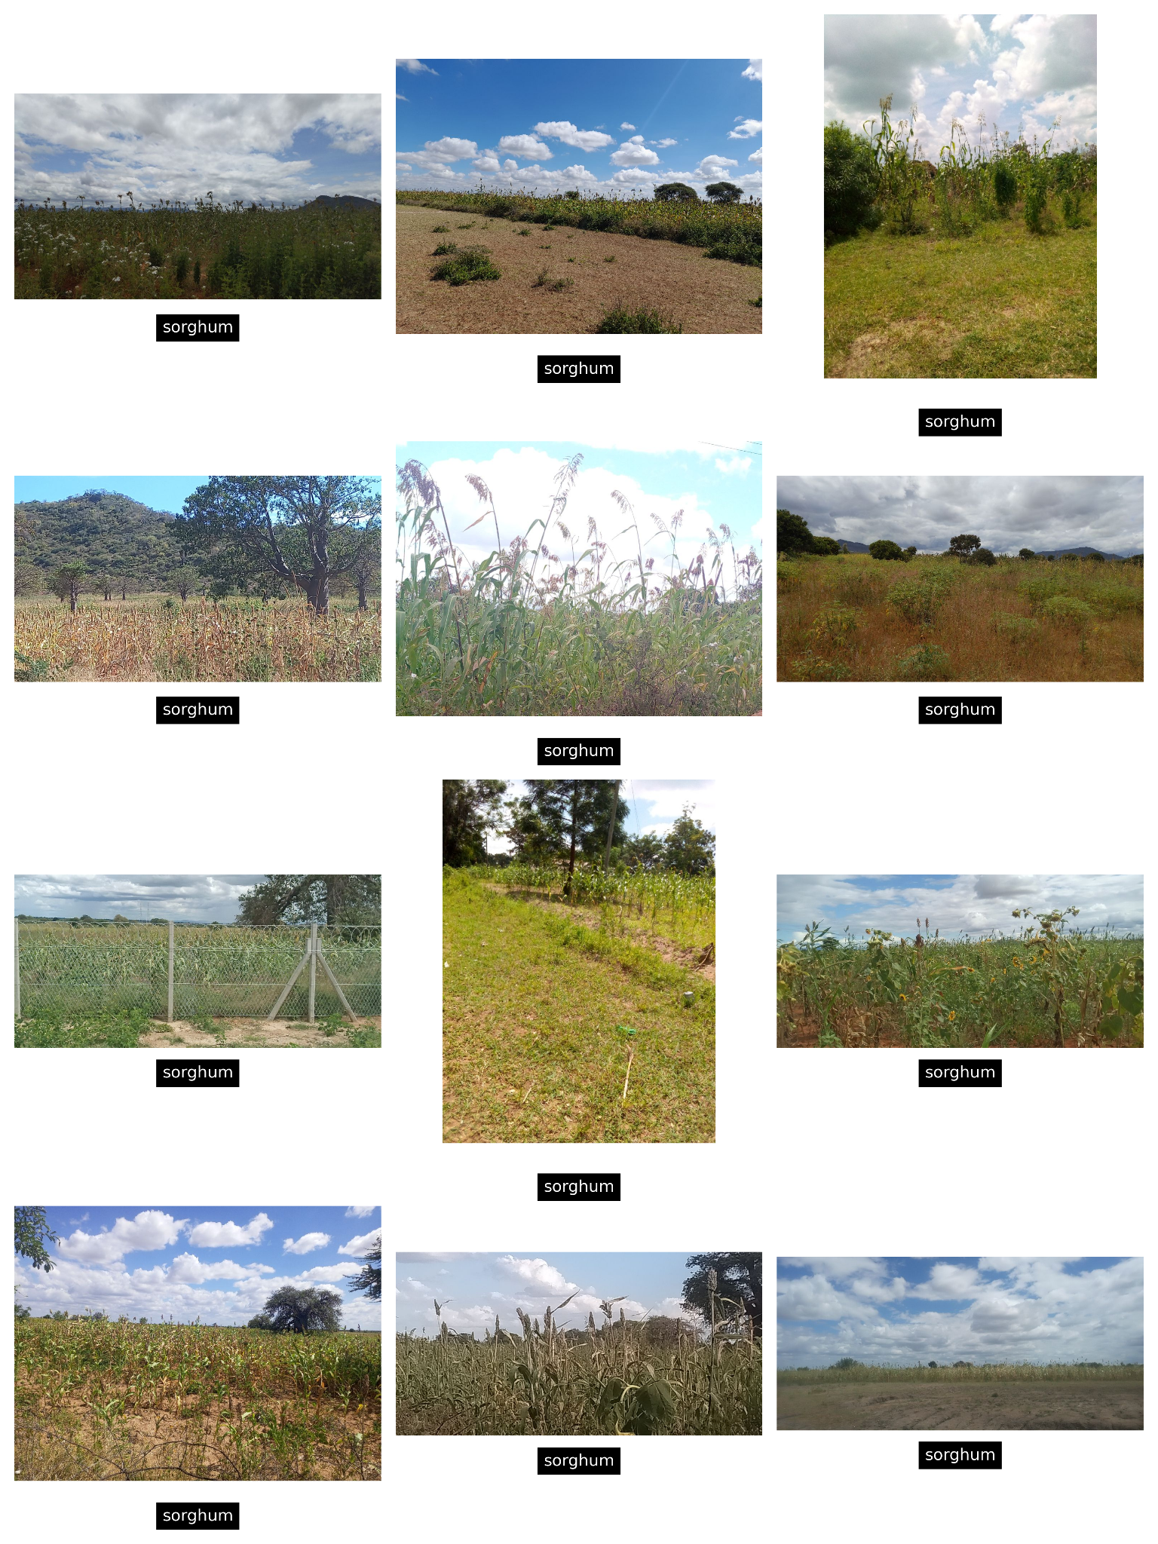

*Figure 8- Images from observations dropped during image quality validation*

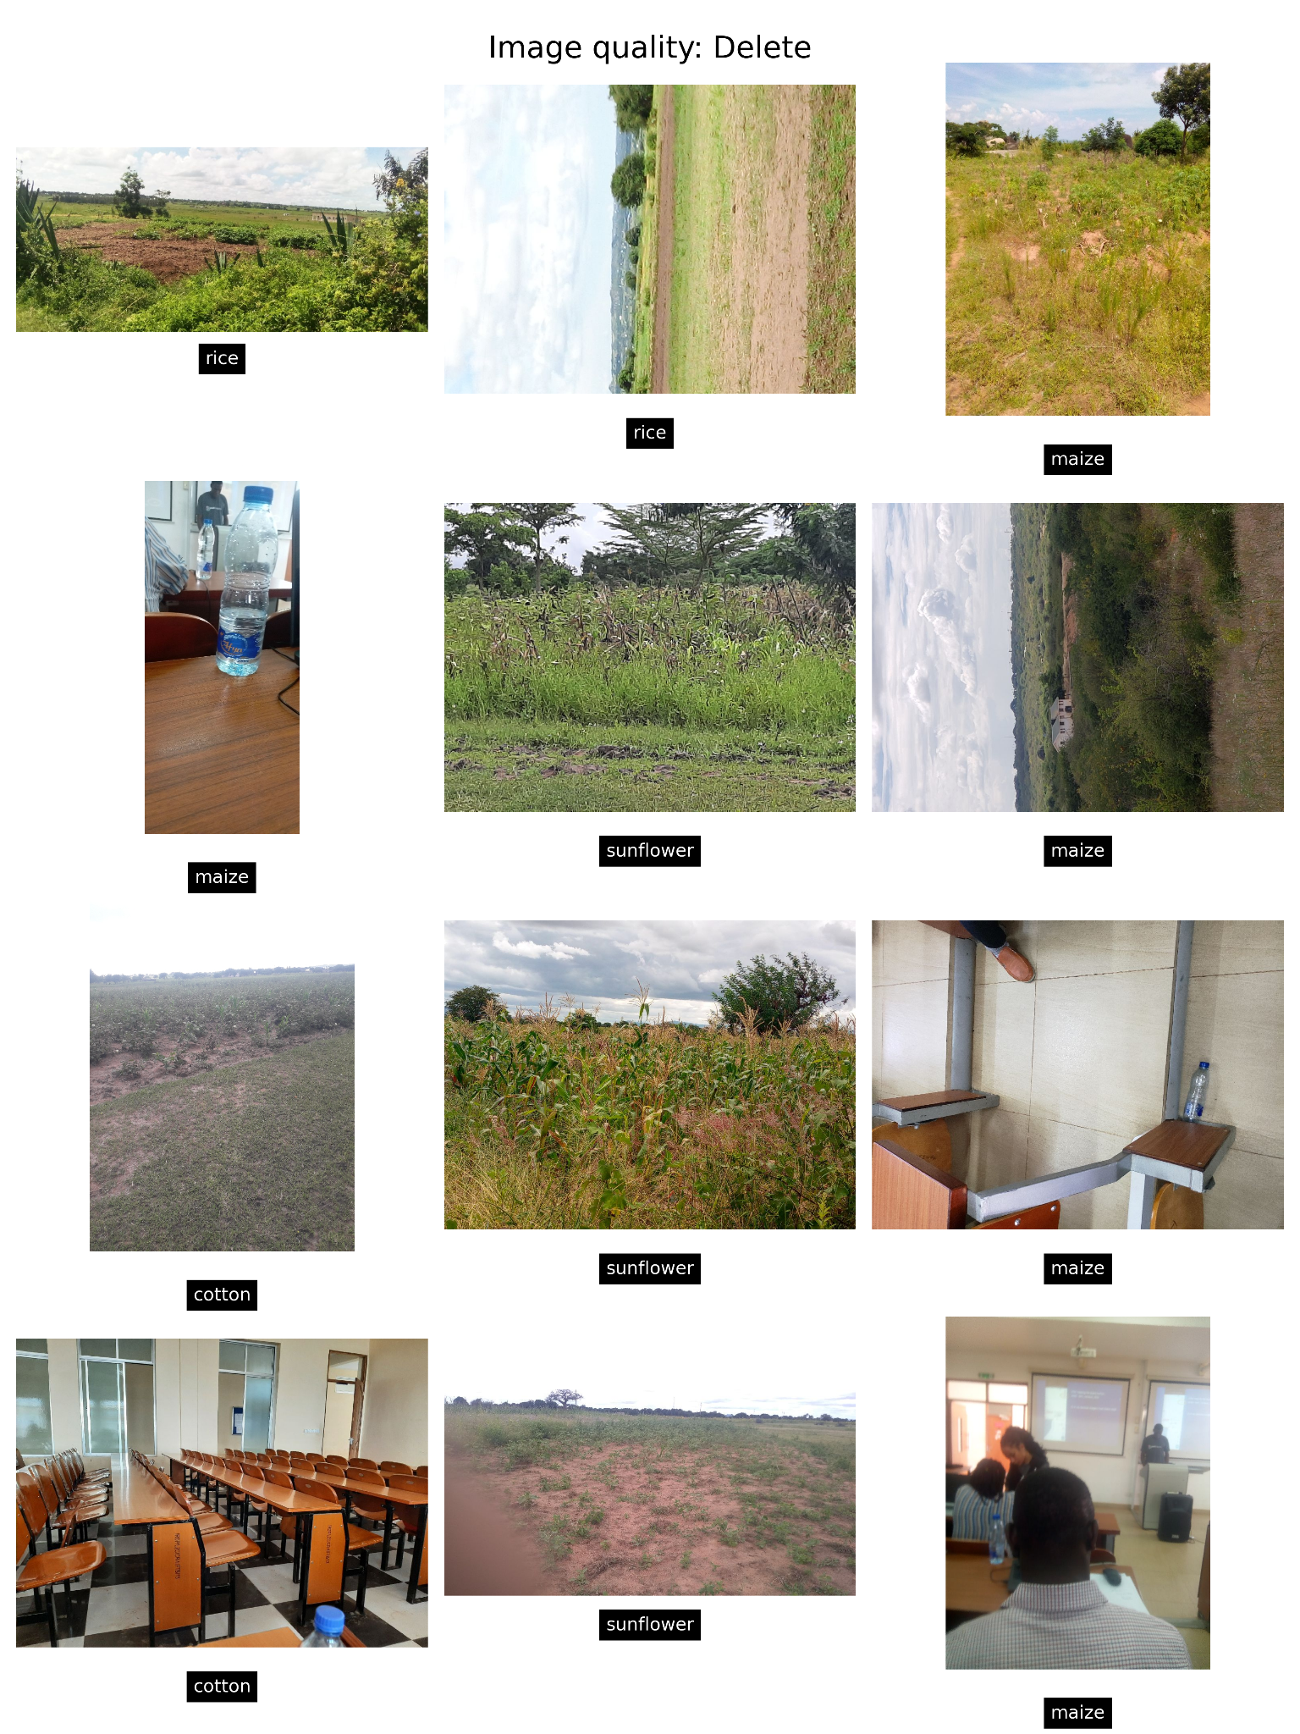

### 

### Model Results

#### Feature Selection

In order to assess the importance of particular time series features for a given image band, we utilize SHAP values (Figure 9). In this example we can see the ranked importance of each band (B11, B12, hue etc) summarized by a particular time series descriptive function (minimum, ts complexity, etc). Additional measures of variable importance were included in the model but are not included here in order to improve readability for a general audience.

*Figure 9 - Mean variable importance as measured by abs mean SHAP values*

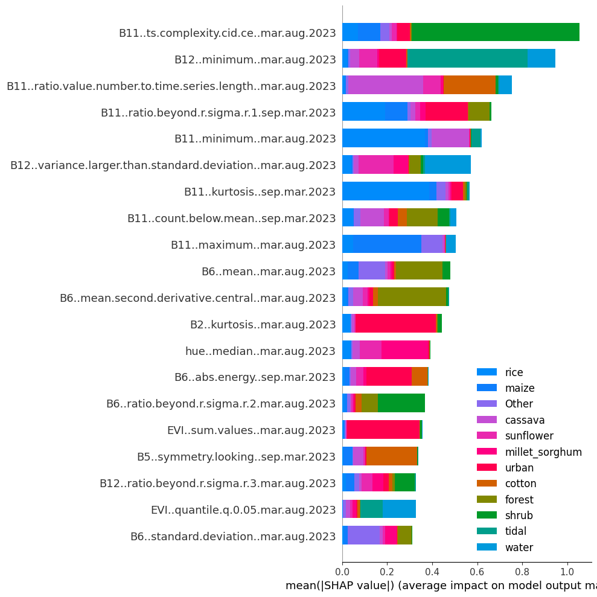

*Length of the bar indicates the mean contribution to model performance, colors indicate the contribution of that variable to each land use class. Variable naming convention “SatelliteBand..TimeSeriesFeature..Season.Year”*

#### Land Use Classification

Model performance is evaluated using k-fold cross validation, as such all results reflect the ability of the model to predict out-of-sample. Overall model performance is evaluated using Cohen’s Kappa statistic (Cohen, 1960) and a confusion matrix representing the results of multiple rounds of out of sample validation, where the true class is on the y-axis and the predicted class is on the x-axis and the percentage of correctly classified observations is indicated by color and numerically.

*Figure 10 - Out-of-sample model performance for land use classification*

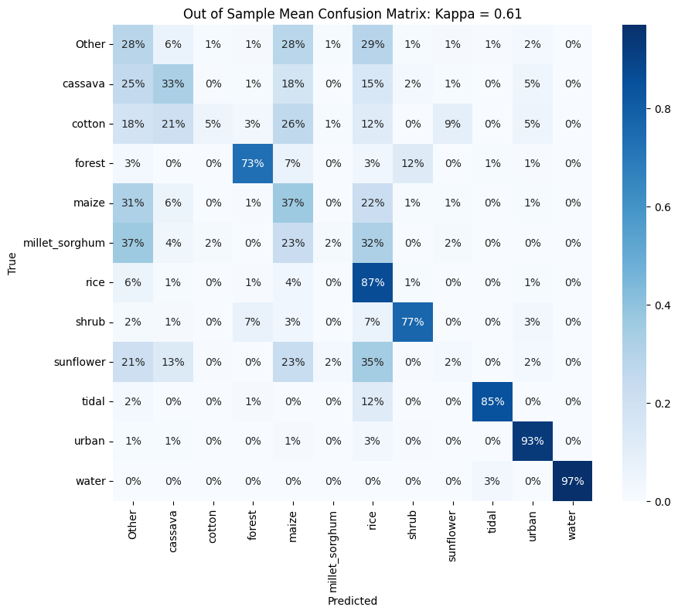  
*Confusion Matrix depicting the percentage of correct and misclassified instances for each crop type. The diagonal elements represent the percentage of correctly classified instances for each class, while the off-diagonal elements show the percentage of misclassifications.*

# Discussion

### Data Quality

This section outlines some of the technical and methodological challenges that impacted the quality of the crop class labels collected by YouthMappers.

#### Field Visit Challenges

One of the significant challenges during the field visits was the difficulty in accessing fields away from highways due to poor road conditions. To overcome this obstacle, 4x4 vehicles were utilized to navigate through the permitted wards, where data collection was allowed. In Mwanza challenging roads limited access to larger fields further afield from urban areas. Additionally, due to time constraints, permissions were limited to certain wards, considerably constraining the distribution of field visits.

Other significant challenges were specific to the homogeneity and distribution of fields selected. The general guidelines on the selection of fields to survey was to prioritize medium or large fields that are continuous with no major tree stands, grassland, or other types of gaps in the crop type identified. Ideally each field would be of a single crop as those are better examples for machine learning algorithms to use as training data. Then, the fields needed to be well distributed. While fields of different crop types could be adjacent or relatively close to each other, the general guidance was to select fields at least one mile or 10-15 minutes apart. Due to land use types being unevenly distributed, the guidance needs to be somewhat flexible yet clear that the main objective is for each team member to avoid quickly collecting samples all in a given area. Adequately distributing the selected fields is more time consuming, going against most workplace expectations for efficiency. As a result, the distribution of crops did not align entirely with the requirements of the project.

*Figure 11 - Tanzanian Crop Seasons*

| **Growing Season** |  |  |  |  |  |  |  |  |  |  |  |
| --- | --- | --- | --- | --- | --- | --- | --- | --- | --- | --- | --- |
| Msimu |  |  |  |  |  |  |  |  |  |  |  |
| Vuli |  |  |  |  |  |  |  |  |  |  |  |
| Masika |  |  |  |  |  |  |  |  |  |  |  |
|  | Jan | Feb | Mar | Apr | May | Jun | July | Aug | Sep | Nov | Dec |

The timing of data collection also presented several challenges, reflecting the country's complex crop seasons and the variability of rainfed agricultural practices. According to the FAO, Tanzania has three growing seasons “Masika” from March to August, “Vuli” from September to Feb, and “Msimu” from November to June (FAO, 2023). Our data collection teams arrived late April and collected data through early May which corresponded with the end of the Msimu season (harvest in May/June) and the early stages of Masika (sowing in February/March). Given the prolonged dry spells during the 2022/2023 Msimu season (FAO, 2023), it is possible that farmers replanted for the upcoming Masika season. In the Arusha region, we observed many immature plants, but in the Mwanza region there is less reliance on the Msimu and Masika seasons and several poorly performing fields were not replanted for the Masika season. Consequently, during the data collection period, many fields contained immature or drought-affected plants, making it challenging to accurately identify the crops.

Despite these challenges, the team diligently collected data points during their field visits. The process involved visiting specific wards in the Mwanza region and systematically documenting information about the crops present in each location. The team employed a combination of observation, and visual documentation to capture relevant data.

These challenges highlight the importance of adapting data collection strategies to account for seasonal variations and local agricultural practices. The team's commitment to overcoming obstacles in data collection demonstrates their dedication to obtaining accurate and reliable land use data in Tanzania.

#### Image Quality Assessment

Although the quality of the data is likely best assessed through validation by professionals of crop images and their corresponding classifications, we do have some indications of training data quality.

The photos taken in conjunction with the land use data play a crucial role in assessing the quality and validity of the data. Upon reviewing these images, we have identified several common issues that can affect the accuracy of the labels. These include: a) low-quality images often caused by white balance problems, b) images taken too close or too far from the field, c) improper orientation, d) lack of detail in capturing leaf/flower/grain characteristics, e) labeling complications arising from intercropping or heterogeneous plots, f) and challenges in distinguishing between maize, sorghum, and millet, especially in early growth stages or in cases of crop failure/damage.

Analyzing the matrix of plot images in Figures 2-7, particularly focusing on the examples of maize images, we find that approximately half of the images clearly indicate maize as the primary crop. However, some images lack sufficient detail for a conclusive assessment, while others suggest the presence of intercropping or alternative crops such as legumes. These challenges are expected given the rapid organization and implementation of the project. On the other hand, crops like rice, cassava, and sunflower appear to have higher-quality images. Figure 8 provides specific examples of low or inaccurate class labels that were excluded during the image quality assessment.

To offer a more detailed evaluation of image quality, Tables 3-5 summarize the findings of the label quality assessment - categorizing the assessment results by crop type, user name, and team. The data suggests that, on average, the generic "shemaps2" user had a relatively low error rate, although the performance of individual users within this category may vary significantly. For instances where Kobo usernames are available, it is evident that certain individuals may contribute to lower performance, as demonstrated by the need to delete a significant portion of person E's submissions due to low quality. Assessments like these can be conducted in the field to provide support and guidance to team members facing challenges. Analyzing the performance by teams, we observe that "Low" quality submissions were primarily associated with teams B and D.

### Suggestions for Data Quality Improvements

Most of the issues described above . To mitigate problems identified here in the future we might consider doing some of the following:

1. Provide more intensive in-person training, including:
   1. Field visits with experts
   2. Visual quizzes
2. Provide extra tools for field assessments, such as:
   1. A field book with relevant images or renderings of plant characteristics at multiple phases of growth. Particularly focusing on leaf/flower/grain as well as height
   2. A field book with a visual guide to assessing field size, perhaps based on size relative to a football field
   3. A phone with a high resolution camera and clear instructions on how to set white balance
   4. Embedding agronomists with teams
3. Assign each users a unique ID or Kobo user name to allow assist with validation
4. Provide feedback to teams after the first day of field collection.
   1. Images should be scored after the first day of collection, tables assessing the performance of teams and individuals can help mitigate ongoing issues.
5. Collect a set of images for each field, including:
   1. A photo of the field with 2/3rds of the images below the horizon
   2. A close up of a single plant
   3. A detail photo of any flower/grain or if not available, the leaf
6. Collect additional numeric indicators including:
   1. Confidence - “0 to 10 how confident you are of your assessment”
   2. Intercropping - “What percentage of the field is the primary crop”
7. Students should be able to see satellite imagery of the location of the field they are attempting to tag.
8. Integrate trained validation teams to drop or correct invalid submissions

In order to achieve better quality data in agricultural surveys, one promising approach is to enhance the quality of the images captured during the survey process and involve professional agronomists in the subsequent validation step. Improved image quality can be achieved through the utilization of higher resolution cameras and more specific direction on the process of image capture, which would capture finer details and provide more accurate visual representations of the agricultural fields under investigation. By ensuring high-quality images, the subsequent data analysis and interpretation would be more reliable and yield more precise results. Furthermore, involving professional agronomists in the validation step would bring their expertise and domain knowledge to verify and validate the collected data against ground truth information. Agronomists possess extensive experience in assessing crop health, identifying specific plant diseases or nutrient deficiencies, and interpreting field conditions. Their involvement would help mitigate errors or inaccuracies that may arise during the data collection process, providing a valuable validation mechanism and enhancing the overall quality and credibility of the survey data.

Of particular importance is improving the quality and quantity of images captured for the validation step. Looking at the examples in figures 10 and 11 below, teams could capture images of the field, a single plant, and a leaf or if possible the grain head.

*Figure 12: Example of photo series of plot, plant, and leaf for cassava*

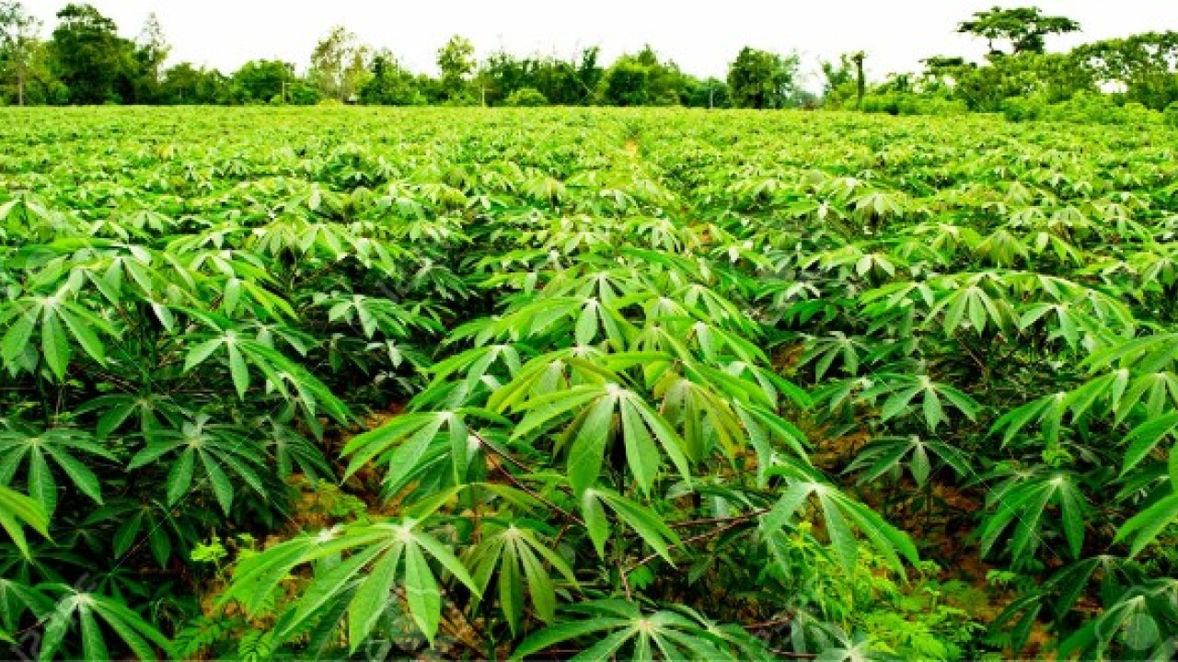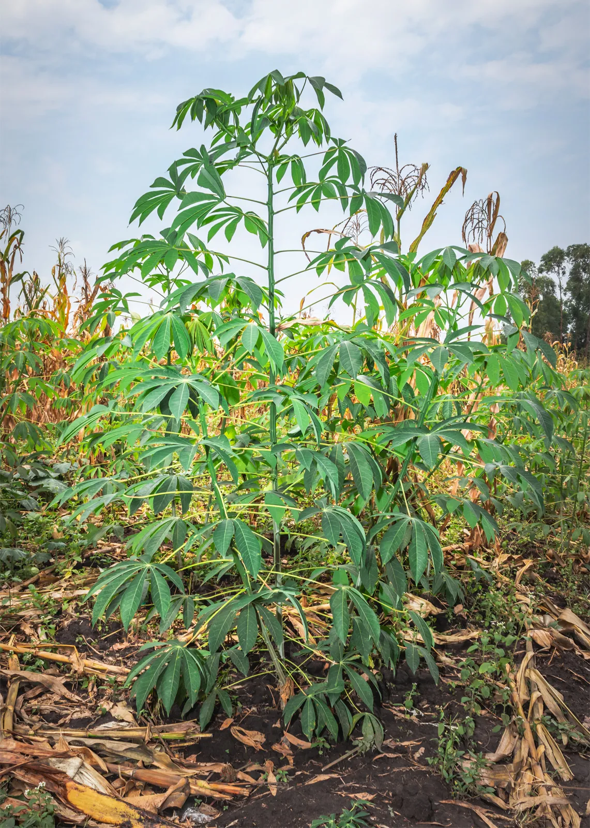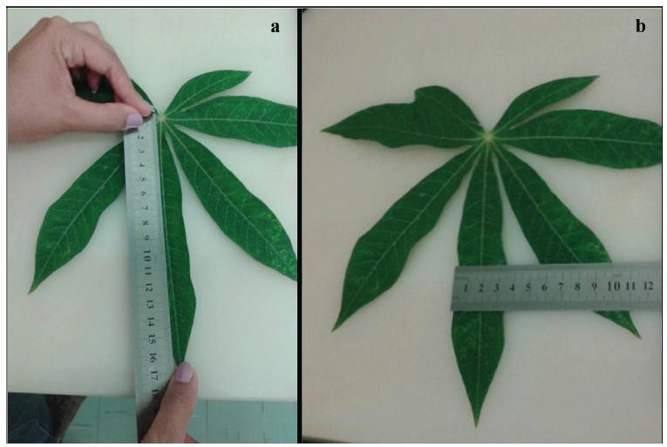

*Figure 13: Example of photo series of plot, plant, and head for millet*

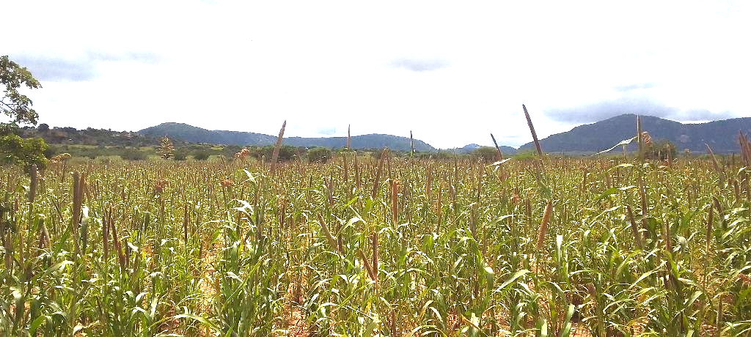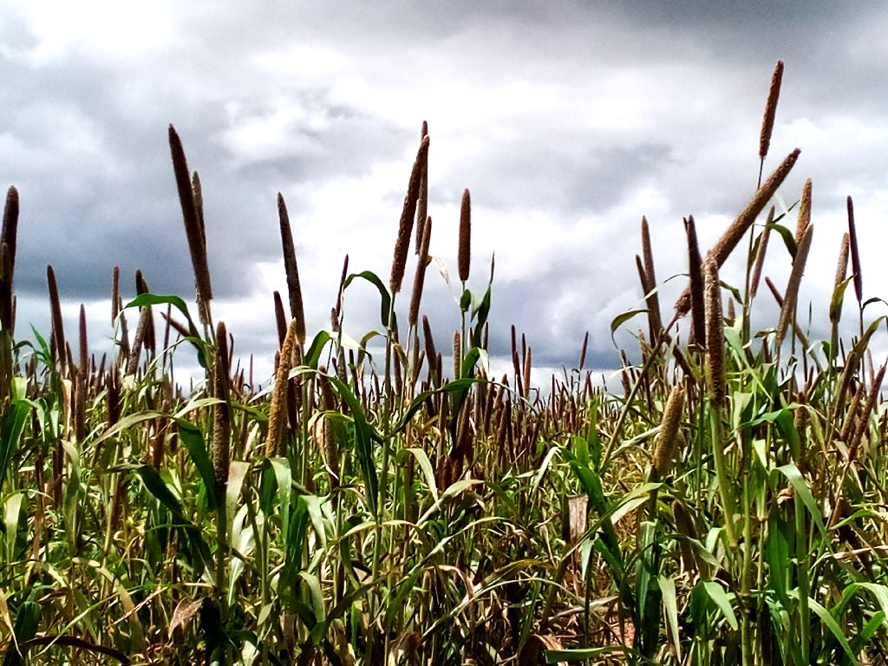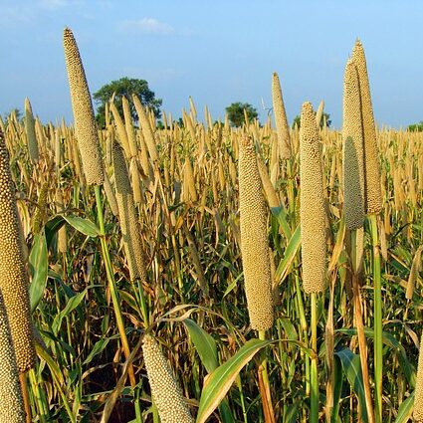

Taken together these changes should be relatively easy to implement and should dramatically improve the quality of the data collected.

#### Land Use Model Quality Assessment

Another indicator of training data quality is the ability to develop models that meaningfully predict the desired crop classifications. Looking at the results from Kpienbaareh et al. 2021 in Malawi. This study had a similar objective - looking to classify a variety of crops using Sentinel 2 data - as well as others. By contrast this study relied on professionally, rather than crowd sourced, ground truth data. In Figure 14, we can see that Kappa Coefficients for Sentinel 2 data are 0.68 in Kpienbaareh et al., which are in line with those obtained in this study (i.e. 0.61, see Figure 10). Although these methods differ, it is a strong indication that the data collected by YouthMappers is of relatively high quality.

*Figure 14: Results summary from a similar study -* Kpienbaareh et al. 2021

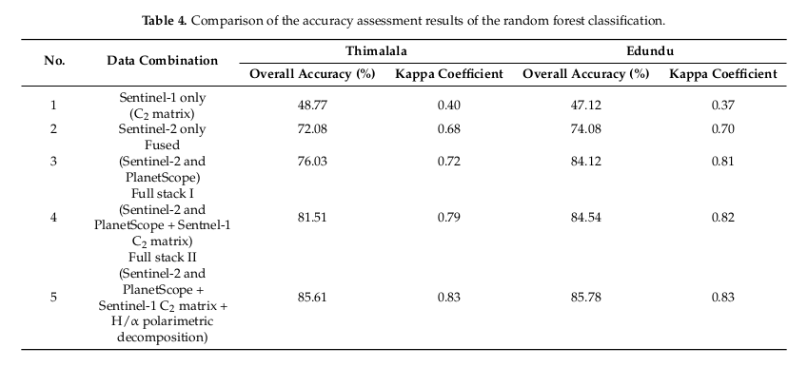

That being said, the confusion matrix (Figure 10) points to significant differences in performance between land use classes. Of the target crop classes, only rice was correctly predicted for the majority of observations out of sample with accuracy approaching 90%. The matrix also points to problems for certain classes. Of particular interest is the confusion between millet, sorghum and maize. This is not surprising as sorghum is a type of millet, and all three come from the same family of seeded grasses called Poaceae (Wikipedia, 2023). As such the plants are very hard to distinguish until they have reached a certain level of maturity and aren’t easily distinguished until the grain filling stage, where seeds are produced. At early stages these plants are largely indistinguishable to the untrained eye. Cotton and sunflowers were also particularly challenging, this is likely due to similarities in the timing of planting and harvest.

Two significant factors that contribute to the challenges observed in the examples discussed above are the relatively low resolution of the Sentinel 2 bands used in the study, ranging from 10 to 20 meters, and the prevalent practice of intercropping or poor crop management. Both of these factors impose limitations on the performance of crop detection and classification models.

The low resolution of the Sentinel 2 bands means that the level of detail captured in the images is constrained. The ability to accurately identify and differentiate specific crops becomes increasingly difficult as the resolution decreases. Particularly as plot sizes approach pixel resolution. This limitation hampers the precision and accuracy of the classification process, particularly when distinguishing between similar crops or identifying small-scale variations within fields.

Additionally, intercropping is present in approximately 30% of observations (Figure 2) and suboptimal crop management practices further complicates the classification task. Intercropping involves growing multiple crops in close proximity, which leads to mixed spectral signatures and challenges in separating individual crop types. Similarly, poor crop management practices, such as inadequate field maintenance or irregular planting patterns, can result in variability within a field that may hinder the classification process.

Taken together, the combination of low-resolution imagery and the presence of intercropping and poor crop management practices sets a performance ceiling for crop detection and classification models. Despite the use of advanced techniques and algorithms, the inherent limitations of the data and agricultural practices pose challenges to achieving higher levels of accuracy and precision in identifying specific crop types.

# Conclusion

This study aimed to assess the quality of land use data collected by YouthMappers and explore approaches for improving data accuracy. The field visit challenges, including the timing of data collection, difficulty traveling the long distance required for field collection, and limitations in encountering certain crops, were acknowledged. Despite these challenges, the team diligently collected data through field visits using observation, and visual documentation. The image quality assessment revealed common issues such as low-quality images, improper orientation, and labeling complications due to intercropping or crop similarity. To enhance data quality, suggestions were proposed, including more intensive training, additional field assessment tools, validation teams, and the involvement of professional agronomists for data validation.

The study also assessed the quality of the data by comparing it to similar studies that utilized professional ground truth data. The findings indicated that the data collected by YouthMappers exhibited relatively high quality, as evidenced by comparable Kappa Coefficients to those obtained in other studies. However, the confusion matrix revealed challenges in accurately predicting certain crop classes, for example millet, sorghum, and maize, which are difficult to distinguish at early growth stages. The limitations of the study, such as the low resolution of Sentinel 2 bands and the prevalence of intercropping and poor crop management practices, set a performance ceiling for crop detection and classification models.

Despite the challenges posed by moderate-resolution imagery and complex agricultural practices, this study provides valuable insights and recommendations for enhancing the accuracy and reliability of crop classification efforts in similar contexts. Future research should focus on implementing these suggestions to further advance the field of crop type classification and contribute to more precise agricultural surveys.

# References

Cohen, J. (1960). A Coefficient of Agreement for Nominal Scales. Educational and Psychological Measurement, 20(1), 37-46.

FAO. (2023.). GIEWS Country Brief: The United Republic of Tanzania. Retrieved from https://www.fao.org/giews/countrybrief/country/TZA/pdf/TZA.pdf

Kpienbaareh D, Sun X, Wang J, et al. Crop type and land cover mapping in northern Malawi using the integration of sentinel-1, sentinel-2, and PlanetScope satellite data. *Remote sensing (Basel, Switzerland)*. 2021;13(4):700.

Lundberg, S. M., & Lee, S.-I. (2017). A Unified Approach to Interpreting Model Predictions. In I. Guyon, U. V. Luxburg, S. Bengio, H. Wallach, R. Fergus, S. Vishwanathan, & R. Garnett (Eds.), Advances in Neural Information Processing Systems 30 (pp. 4765-4774). Curran Associates, Inc. Retrieved from <http://papers.nips.cc/paper/7062-a-unified-approach-to-interpreting-model-predictions.pdf>

Wikipedia contributors. (2023, July 18). Millet. In *Wikipedia, The Free Encyclopedia*. Retrieved 11:06, July 18, 2023, from https://en.wikipedia.org/wiki/Millet